4. Strategic Rationale
The deal is a scale-and-diversification play funded by a clean balance sheet. Sun Pharma converts ~$3.1bn of net cash and new debt into ~$1.9bn of incremental EBITDA, a US commercial platform, a women’s-health franchise, and a top-10 biosimilars position — at ~6.2x EV/EBITDA. Management guides to >$350m of cost synergies within 2–4 years and EPS accretion from the first full year. The strategic logic is sound; the execution risk is leverage and Organon’s decline.

4.1 Why Sun Pharma is acquiring Organon
- Scale. Combined revenue ~$12.4bn moves Sun into the top 25 global pharma companies.
- Diversification. Innovative medicines rise to ~27% of combined sales; the combined group runs three platforms — innovative medicines, established brands, biosimilars.
- US commercial infrastructure. Immediate depth in the world’s largest market, complementing Sun’s specialty push.
- Biosimilars platform. Acquiring Organon’s unit is faster than building — supports Sun’s top-10 biosimilars goal.
- New-market entry. Organon opens China (its ~$800m revenue base vs Sun’s negligible presence; a ~$150bn market growing 5–7%) and South Korea (Sun absent today).
- Cheap entry multiple. ~6.2x EV/EBITDA and ~1.9x EV/revenue — a margin of safety.

4.2 Why Organon agreed
- Depressed equity value. ~$8.6bn gross debt against a small equity base; the 2025 dividend cut (to prioritise debt paydown) compressed the share price.
- Certainty in cash. $14.00/share all-cash removes execution and market risk for shareholders holding a declining-brands business.
- Leadership vacuum. The October 2025 CEO resignation and Nexplanon sales-practice probe left the company without a permanent CEO — a sale to a strategic acquirer resolves the overhang.
- Better owner. Sun’s low-cost manufacturing and EM distribution can extract more value from Organon’s assets than Organon can standalone.

4.3 Synergy taxonomy
Company guidance quantifies cost synergies only. Revenue, financial and tax synergies below are framed qualitatively with illustrative ranges — flagged as analyst estimates, not disclosed figures.
Synergy type | Source | Magnitude | Basis
Cost | Procurement, supply-chain consolidation, shared R&D, consolidated marketing, workforce alignment | >$350m run-rate in 2–4 yrs (up to ~$500m) | Company guidance
Operational | Move Organon manufacturing/API into Sun’s low-cost, vertically integrated base | Embedded in cost synergies | Analyst est.
Commercial (revenue) | Push Organon brands through Sun’s EM distribution; enter China / South Korea | Not quantified; multi-year upside | Mgmt (qualitative)
Financial | Interest tax shield on ~$9.5bn acquisition debt; USD target cash flows naturally service USD debt (currency match) | Illustrative | Analyst est.
Tax | India-outbound structuring via Sun Pharma USA; deductibility of acquisition interest against US target income; treaty-efficient repatriation | Illustrative | Analyst est.
Cost of capital | Redeploy Organon’s cash flow to deleverage from ~2.3x over 4–5 yrs, lowering blended cost of capital over time | Illustrative | Disclosed leverage path
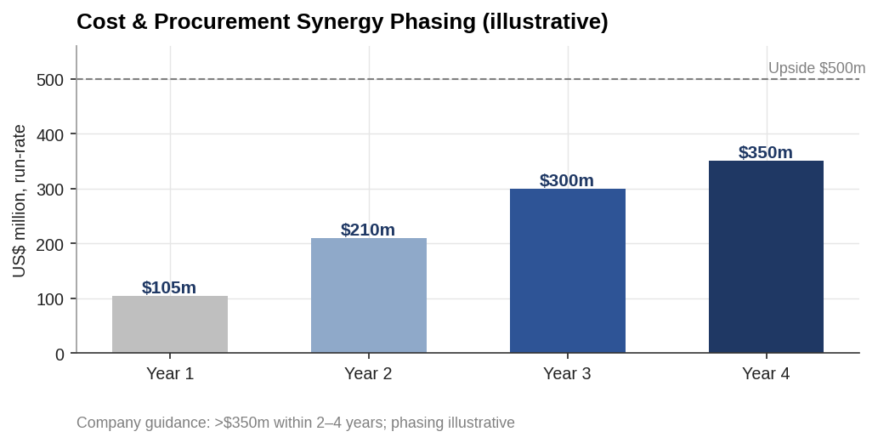
Cost & procurement synergy phasing (illustrative)
Cost synergies. The disclosed >$350m is ~5% of combined revenue — credible for a horizontal pharma combination with procurement and supply-chain overlap. Phasing is illustrative (guidance is a 2–4 year window).
Commercial synergies. The clearest upside is geographic: Organon already earns ~$800m in China where Sun is negligible, and operates in South Korea where Sun is absent. Cross-selling Organon’s established brands through Sun’s emerging-market network is the revenue thesis — real but unquantified and slower to bank than cost synergies.
Financial and tax synergies (the cross-border differentiator). Funding runs through Sun Pharma USA, an offshore acquisition vehicle. Two effects: (i) ~$9.25–9.75bn of acquisition debt generates an interest tax shield, deductible largely against US-sourced target income; and (ii) Organon’s USD cash flows naturally service USD-denominated debt, reducing currency mismatch. Structuring the acquisition offshore (rather than from the Indian parent) also navigates Indian outbound-financing constraints — the same structuring theme that recurs in the LBO analysis. These are genuine value levers but depend on holding-structure design and are sized in the merger and financing chapters, not asserted here.

4.4 Long-term strategy and the deleveraging path
The financing plan — ~$2–2.5bn internal accruals plus ~$9.25–9.75bn debt — takes Sun from net cash to ~2.3x net debt/EBITDA at close, with paydown over 4–5 years. Organon’s high cash conversion is the deleveraging engine: established-brands cash flow services and retires the acquisition debt while Sun tilts the combined mix toward specialty, biosimilars and EM growth.
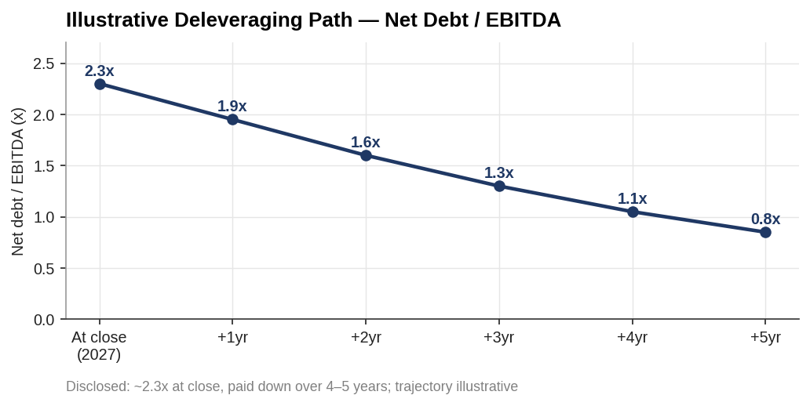
Illustrative deleveraging path

4.5 Strategic conclusion
The rationale holds on four legs: scale, diversification, cheap entry multiple, and a credible cost-synergy and deleveraging path. The bet is that Sun’s balance sheet and low-cost platform can hold Organon’s EBITDA long enough to deleverage while capturing China/EM revenue upside. The two threats to the thesis: established-brands erosion outrunning synergy capture, and the Nexplanon probe impairing the Women’s Health trajectory. Both are quantified in the valuation, merger and risk chapters.

Assumptions & sources
- Cost synergies of >$350m (up to ~$500m) within 2–4 years and EPS accretion from year one are company guidance. Synergy phasing (Yr1–4) is an illustrative analyst schedule.
- Financing split (~$2–2.5bn internal accruals; ~$9.25–9.75bn debt) and ~2.3x net leverage at close with 4–5 year paydown are disclosed; the deleveraging trajectory shown is illustrative.
- Revenue, financial and tax synergies are analyst estimates, explicitly not disclosed dollar figures; sized later in the model.
- China revenue (~$800m) and market size (~$150bn, +5–7%) per management commentary.
- Management commentary attributed to Sun Pharma MD Kirti Ganorkar; Dilip Shanghvi is founder and Chairman.
Sources: Sun Pharma / Organon definitive-agreement press releases (Apr 2026); Sun Pharma investor commentary; Business Standard, Forbes India, Dermatology Times, IntuitionLabs deal analyses. Full sourcing map in 05_Data/DATA_SOURCES.docx.

